Substance User Measurement Identification Tool

  - User Guide
Ver. 7.22.2017

Contents
1. Introduction 3
2. Search for Substance Use Measures 3
2.1 General Search 3
2.2 Advanced Search 4
2.3 Listing All Measures 5
3. Administration Tool 5
3.1 Add/Edit Measure in SUMI 5
3.2 Review User Feedback 8
4. Feedback 9

Introduction
The Substance User Measurement Identification (SUMI) tool is a web-based tool to advise the selection of substance use measures that have strong psychometric properties, and are relevant to specific populations, geographies and cultures.
The algorithm of SUMI is developed based on the meta-analysis on substance abuse measurement conducted by the HPTN Substance Use Scientific Committee to ensure the tool produce consistent and accurate outcome for the scientific community.

Search for Substance Use Measures

General Search
The measure search page serves as the landing page (Figure 1) of the SUMI tool. At this page, you will be able to identify the search criteria by turning on/off each criterion.
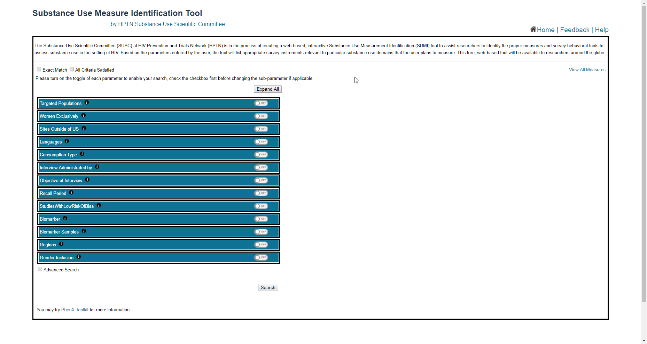
Figure 1: Landing page
The toggle to the right of each parameter indicates the visibility of child parameters under each parental parameter. The Expand All button will turn on/off the visibility of all parameters, turning off all parameters will also reset them back to default value.
Hovering your mouse cursor to the information icon will expose a brief description of the parameter.
Check the checkbox in front of each sub-parameter to render a search. The search result will be generated to the right side of the page instantly, and be changed as you alter the search criteria (Figure 2).
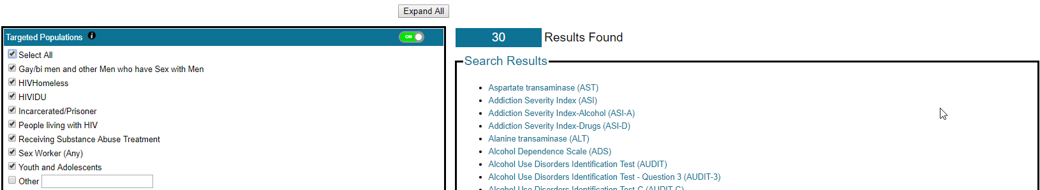
(Figure 2: Search results)
By default, the search engine will find the measures that satisfy at least one of the selected parameters. If you would like to find the measure that satisfy all parameter, you need to check the checkbox of “All Criteria Satisfied”, which can be located at the top of all search parameters.

Advanced Search
The SUMI also provides advance search feature for advanced user to identify the desire the accuracy and efficacy of the measure.
To enable the Advanced Search parameters, check the checkbox of advance search (Figure 3).
The advanced search is for limiting the scope of search by identifying desired measure’s validity, reliability, sensitivity or specificity etc. Therefore, the search result will only list the measure that satisfy the selected general search parameters and the selected advanced search parameters.
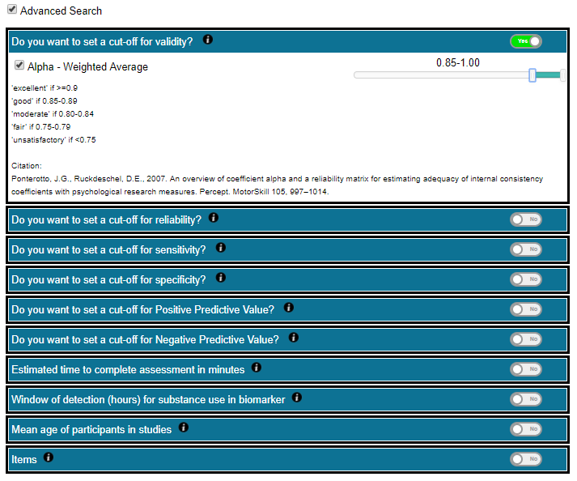
(Figure 3: Advanced search)

Listing All Measures
If you just want to review all measures that are supported by the SUMI tool, you may click the link “View All Measures” at the top of the search result area to open a list of all measures.

Administration Tool

Add/Edit Measure in SUMI
As the substance use research evolves, and new scientific findings being discovered, the validity of existing measures might be changed or new measure could be developed. In order to synchronize with the scientific world, the SUMI system provides an administration module for authorized user to manage the algorithm of the search engine, as well as add new measures into the system, so that the SUMI tool can produce up-to-date search results for end users.
To enter administration module, you will have to obtain login credential from the SUMI tool owner. The login entrance can be located at the bottom of the search page, under the HPTN logo (Figure 4).
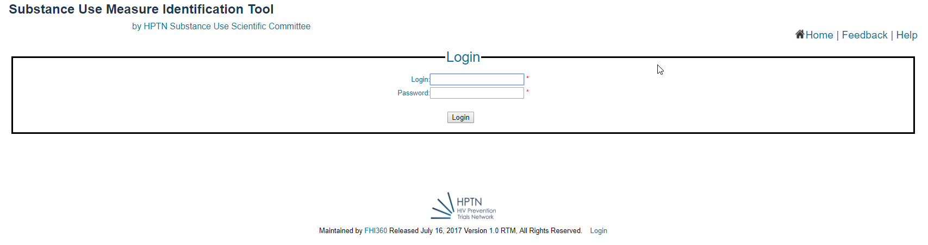
(Figure 4: Login to Administration module)
Once logged in successfully, you may enter the measure name or just click search button to look for the measure you would like to edit (Figure 5).
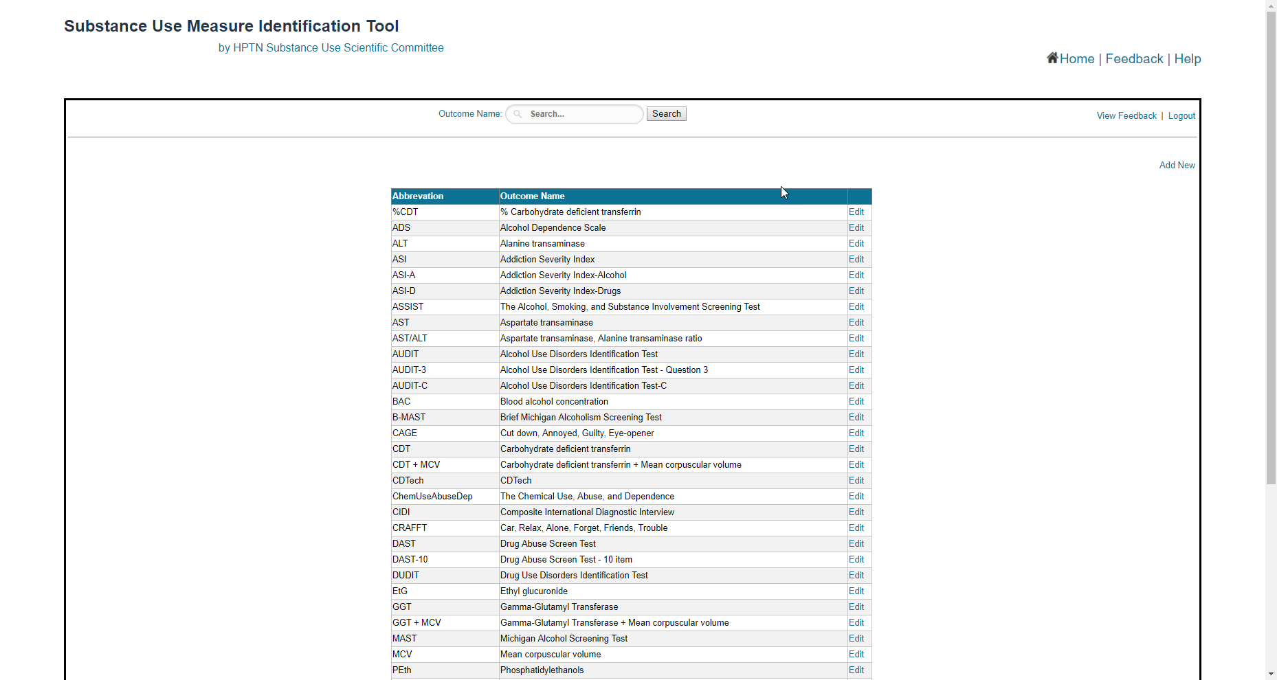
(Figure 5: Search for measure to edit)
Click Edit link next to the name and description of the measure, navigate to the editing page of the selected measure. The Enable checkbox is to activate/deactivate the measure (Figure 6). In this page, you can change the description of the measure, the relationship between the measure and the search parameters, etc. The changes made in this page will take effect immediately once saved to the system.
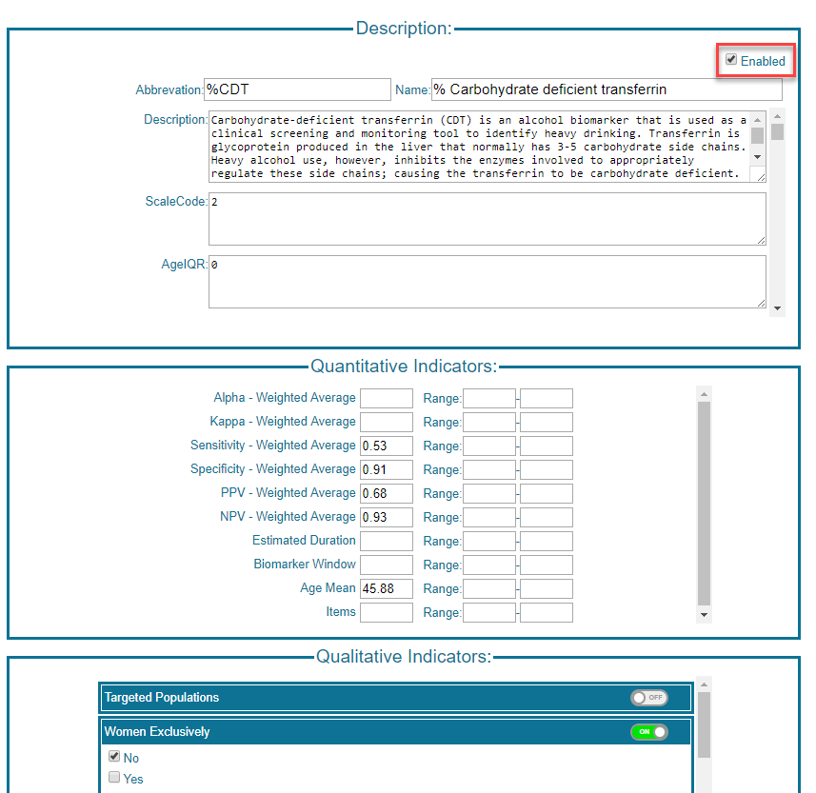
(Figure 6: Editing the algorithm of the search engine)
Click Save to save the change, click back to go back to the previous page without save the changes.
Click “Add New” at the right side of the page to initiate building a new measure into the SUMI tool (Figure 7). You will need to define the search parameter and description for the new measure in order for it to be searchable.
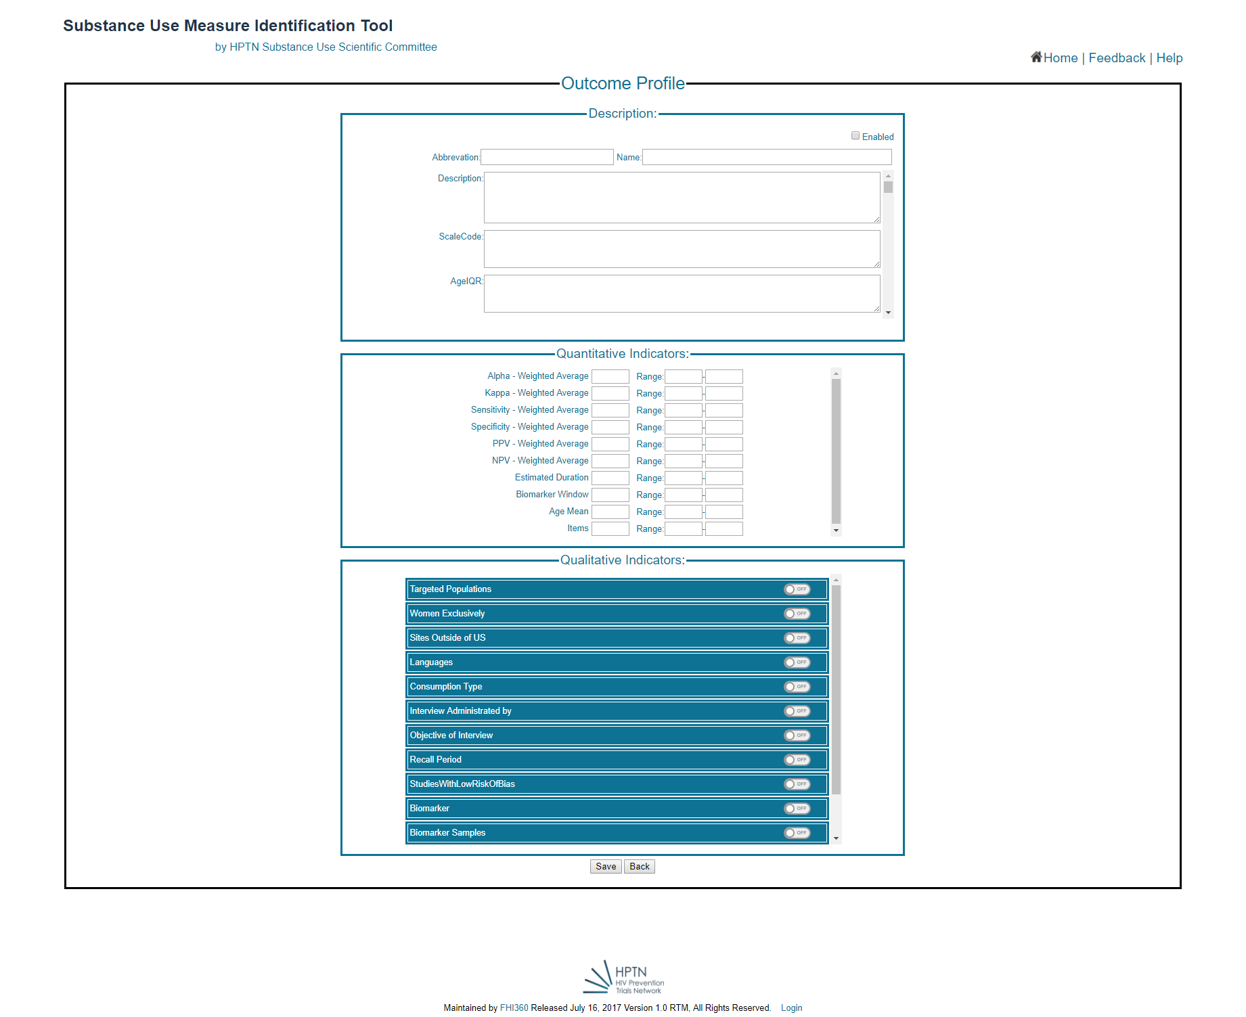
(Figure 7: Adding new measure)

Review User Feedback
In this module, authorized user can review the feedback submitted by the end users.
Click View Feedback at the right side of the page to enter. You can search for a specific user’s feedback by searching for user’s name, or execute an open search by selecting the beginning of the date that you want the system to search feedback from (Figure 8).
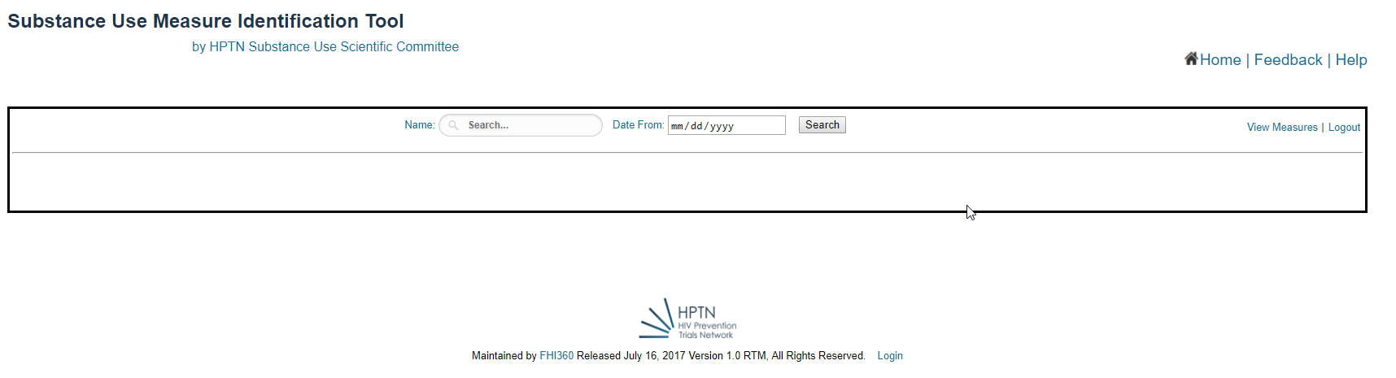
(Figure 8: User Feedback Review)

Feedback
The SUMI tool provides a feedback collection module to allow end users to submit their feedback, comments to the SUMI system administrator.
Click the Feedback link next to the Home button to enter feedback tool (Figure 9).
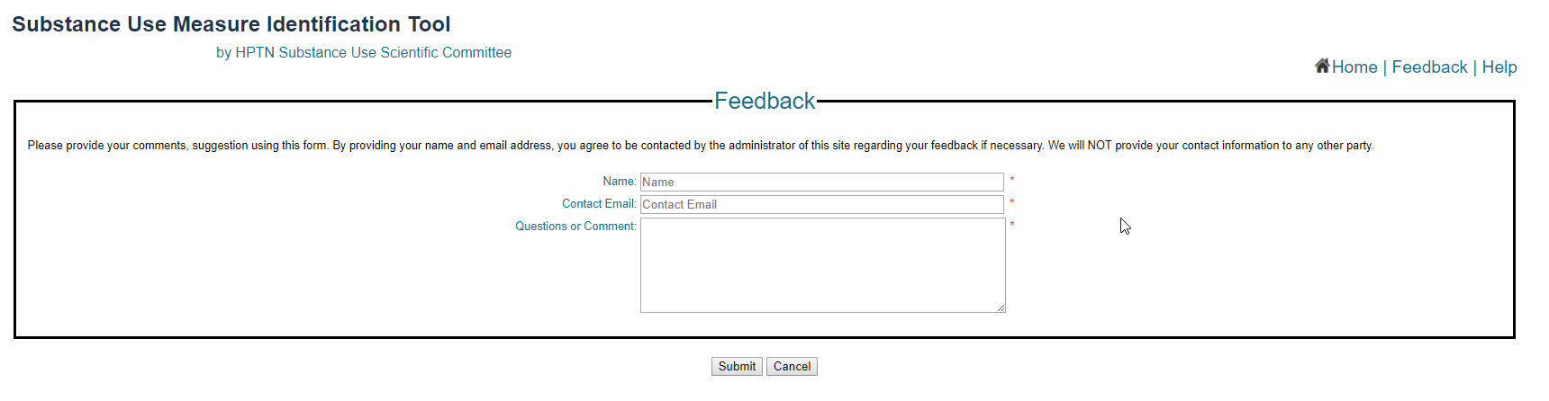
(Figure 9: Submitting User Feedback)

